**Capstone Project Synopsis: AI-Based Personal Assistant in C++**

**Title: AI-Based Personal Assistant in C++**

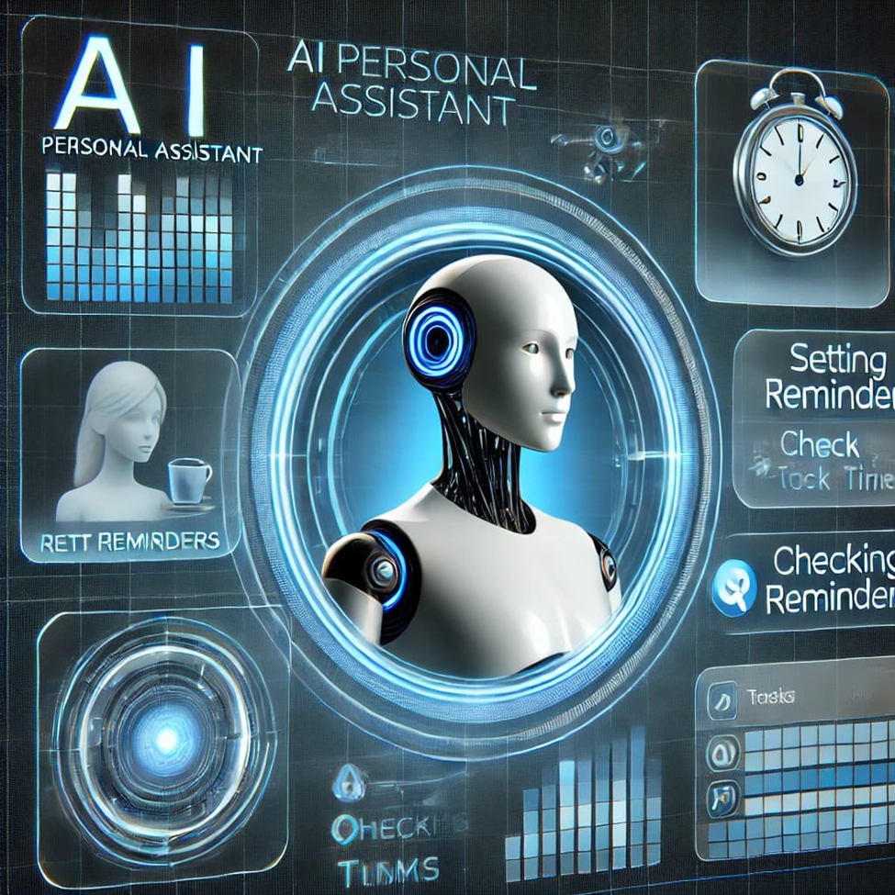

**Introduction:**

In today's digital age, AI-powered personal assistants have become essential tools for increasing productivity and managing tasks efficiently. These systems use Natural Language Processing (NLP), Machine Learning (ML), and other AI techniques to interact with users in a human-like manner. This project aims to build an AI-based personal assistant in C++, providing users with an interactive platform to handle tasks such as setting reminders, searching the web, managing files, and more.

**Objective:**

1.The main objectives of the project are:

2.To develop an intelligent personal assistant using C++.

3.To enable voice-based or text-based interaction for various tasks.

4.To implement core functionalities like web search, file management, and task reminders.

5.To explore and utilize AI techniques within the C++ environment, focusing on efficiency and low resource consumption.

**Methodology:**

1.Requirement Analysis: Identify and gather necessary tools, libraries, and algorithms for developing the assistant.

2.Natural Language Processing (NLP): Utilize existing NLP libraries or algorithms to process user input.

3.Voice Recognition (Optional): Integrate a speech-to-text engine for voice commands (if applicable).

4.Task Management: Design algorithms to handle task scheduling, reminders, and file operations.

5.Web Search: Implement APIs for web search functionalities.

**Testing:** Conduct multiple test cases to evaluate the performance, accuracy, and usability of the system.

Optimization: Fine-tune the application for real-time performance in a resource-efficient manner.

**Expected Outcome:**

1. A functional AI-based personal assistant capable of understanding user commands through text or voice.

2. Ability to execute tasks like setting reminders, web searches, and file management.

3.An efficient, real-time system implemented in C++ that leverages AI techniques with minimal resource usage.

4.A scalable architecture that can be further expanded with additional features.

**Conclusion:**

This project will provide a practical implementation of AI-powered personal assistant technology using C++, focusing on usability, efficiency, and accuracy. It will highlight the potential of AI in everyday task management, showcasing the strengths of C++ in developing such systems while addressing challenges such as NLP integration and system optimization. The project could serve as a foundation for further research or development of more advanced AI personal assistants.